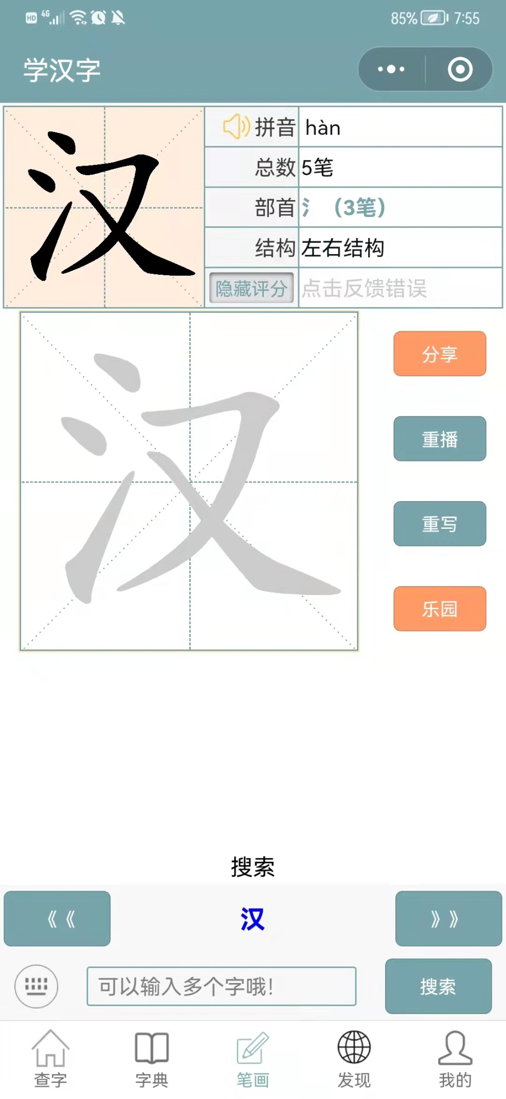

**5 strokes**

**structure**

**Radical**

**Replay**

**Input characters**

**Go**